Course: PFP191 - Programming Fundamentals with Python

Student Management System

Group: 4
Group Members | Nguyễn Thái Huy - SE211528  Trần Võ Hồng Ngọc - SE211681  Vũ Ngọc Anh - SE211294  Nguyễn Thái Sơn - SE211746
Lecturer | Lê Thị Hồng Nga
Class | AI2102

Ho Chi Minh, Oct – 2026

Table of Contents

Table of Contents 2
1. Introduction 3
1.1. Project Description 3
1.2. Project Team 3
2. Requirement Analysis & Decomposition 4
2.1. Data 4
2.2. Functions 4
3. Algorithm Design & Flowcharts 6
3.1. Main System Navigation & CLI Menu 6
3.2. Student Management Module 9
3.3. Result Management & Evaluation Logic 16
3.4. File I/O & Exception Handling 19
4. Implementation of Basic Functions 23
4.1. Main System Navigation & CLI Menu 23
4.2. Student Management Module 25
4.3. Result Management & Evaluation Logic 32
4.4. File I/O & Exception Handling 40
5. Object-Oriented Design (OOP) 46
6. File I/O & Testing 46
7. Experimental Results 46
8. Appendix 46

1. Introduction

1.1. Project Description
This project implements a robust, console-based Student Management System developed in Python. Designed for academic administration, the software streamlines core institutional workflows—including student profile tracking, course enrollment, and automated grade evaluation. Built following Object-Oriented Programming (OOP) principles and a modular architecture, the system guarantees data persistence through plain-text file handling, alongside defensive exception management to ensure a seamless user experience.

1.2. Project Team
# | Student ID | Full Name | Completion Level | Tasks Performed
1 | SE211528 | Nguyễn Thái Huy | 100% | Implemented main system CLI navigation (main.py), application lifecycle control, cross-module integration, and report compilation.
2 | SE211681 | Trần Võ Hồng Ngọc | 100% | Implemented Student Management module (student_management.py): console input validation helpers and core functions (addStudent, updateStudent, filterStudents, displayActiveStudents).
3 | SE211294 | Vũ Ngọc Anh | 100% | Implemented Result Management module (result_management.py): two-attempt grading evaluation logic, numerical validation, and grade record management.
4 | SE211746 | Nguyễn Thái Sơn | 100% | Implemented File I/O module (file_io.py): delimited plain-text persistence for students and results with defensive try-except-finally exception handling.

2. Requirement Analysis & Decomposition

2.1. Data
# | Name | Data Type | Description
1 | Student_ID | String | Unique student ID. The program checks for duplicate student IDs before adding a student.
2 | Full_name | String | Student's full name
3 | Date_of_birth | String | Date of birth (DD/MM/YYYY)
4 | Gender | String | Gender(Male/FeMale)
5 | Class_name | String | Class code
6 | Phone | String | A 10-digit phone number that must start with 0.
7 | Email | String | Mandatory; must be a university email (@fpt.edu.vn) or Gmail (@gmail.com).
8 | Status | String | Academic status (Active / Inactive / Graduated)
9 | Course_Id | String | Course code (e.g., PFP191, CSI106, MAE101, ...)
10 | Course_name | String | Full course title
11 | Semester | String | Enrolled semester (e.g., Fall2026)
12 | Credits | Integer | Number of academic credits
13 | Grade_FE | Float | Final Exam score, stored as a string after numerical validation. Valid score range: 0–10.
14 | Grade_RE | Float | Retake Exam score, stored as a string. It is empty if no retake is required. Valid score range: 0–10 when entered. (FE<=4)
15 | Result_status | String | Course passing status (Pass / Fail)

2.2. Functions
# | Function | Description
1 | Student Management | Manage students records and academic profiles
2 | Result Management | Manage course grades, exam, and evaluate performance
3 | File I/O & System CLI | Persistent storage with text files and console user interface
4 | Main System Navigation & CLI

1. Student Management Module:
1.1. addStudent(student_list) – Adds a new student record after validating the input and checking for duplicate student IDs.
1.2. updateStudent(student_list) – Searches for a student by ID and updates the student's profile information if the record exists.
1.3. filterStudents(student_list) – Filters and displays students whose class name or academic status matches the entered filter condition.
1.4. displayActiveStudents(student_list) – Displays students whose academic status is Active.
1.5. displayAllStudents(student_list) – Displays all student records or an appropriate message if the student list is empty.
1.6. student_sub_menu(student_list) – Displays and handles the Student Management submenu.
2. Result Management Module:
2.1. addCourseGrade(result_list, student_list) – Adds a course-result record after checking whether the student exists and whether a record for the same student and course already exists.
2.2. updateGradeOrStatus(result_list) – Updates an existing course-result record identified by student ID and course ID.
2.3. searchEnrollments(result_list) – Searches for and displays course-result records associated with a student ID.
2.4. displayExamResults(result_list) – Displays all course-result records sorted by result status in descending lexicographical order.
2.5. displayPassedStudents(result_list) – Displays course-result records whose status is Pass.
2.6. result_sub_menu(result_list, student_list) – Displays and handles the Result Management submenu.
3. File I/O & System CLI:
3.1. loadFromFile(FilePath) – Loads student records from a text file and returns a list of student dictionaries.
3.2. saveToFile(FilePath, DataList) – Saves student records to a text file.
3.3. loadResultsFromFile(FilePath) – Loads course-result records from a text file and returns a list of result dictionaries.
3.4. saveResultsToFile(FilePath, DataList) – Saves course-result records to a text file.
4. Main System Navigation & CLI
4.1. display_main_menu() – Displays the main command-line menu.
4.2. main() – Loads the student and result records, controls the main application loop, calls the appropriate submenu, and saves both lists when the user selects Save and Exit.

3. Algorithm Design & Flowcharts
This section presents the detailed functional specifications, pseudocode implementations, and visual flowchart references for all core modules of the Student Management System, contributed by the project team members.

3.1. Main System Navigation & CLI Menu
Detailed Function Specification (main):
- Start/End Points: Automatically executes upon running main.py; terminates when the user selects exit (Choice 3).
- Input Data: None (System automatically loads records from storage).
- Output Data: Void (Data mutations handled via in-memory lists and file I/O operations).
- Processing Steps: Loads existing records via loadFromFile(), initiates an infinite WHILE True loop for the session, displays the CLI menu, captures user input, and routes execution using conditional branching (if-elif-else).

Pseudocode:
FUNCTION main():
CALL loadFromFile("students.txt")
CALL loadResultsFromFile("results.txt")
WHILE True:
DISPLAY "=== STUDENT MANAGEMENT SYSTEM ==="
DISPLAY "1. Student Management"
DISPLAY "2. Result Management"
DISPLAY "3. Save and Exit"
INPUT choice
IF choice == 1 THEN
CALL openStudentSubMenu()
ELSE IF choice == 2 THEN
CALL openResultSubMenu()
ELSE IF choice == 3 THEN
CALL saveToFile("students.txt")
CALL saveToFile("results.txt")
PRINT "Exiting program. Goodbye!"
BREAK
ELSE
PRINT "Invalid choice! Please select between 1 and 3."
END IF
END WHILE
END FUNCTION
Flowchart Illustration:
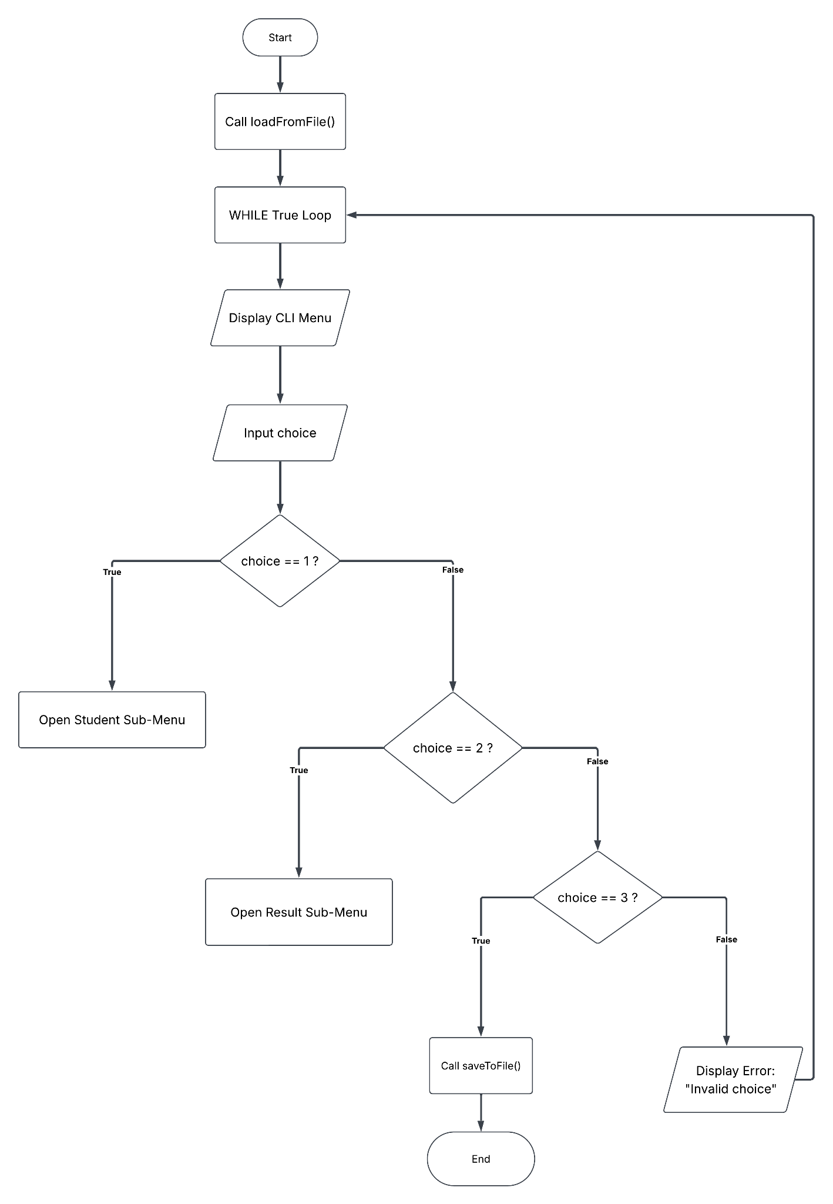

3.2. Student Management Module
Detailed Function Specification:
- Covers 4 core functions: addStudent, updateStudent, filterStudents, and displayActiveStudents.
- addStudent: Checks if student_id already exists. If duplicate, returns an error; otherwise, collects input, creates a new student record, and appends it to the list.
- updateStudent: Searches for student_id. If found, prompts for new attributes and updates the record; otherwise, returns a "not found" error.
- filterStudents & displayActiveStudents: Iterate through the student list using FOR loops to filter by criteria (class/status) or display active records.
Pseudocode:
// 1. ADD STUDENT
FUNCTION addStudent(student_id)
BEGIN
// STEP 1: Check whether the Student ID already exists
SET studentExists = SearchInStudentList(student_id)

// STEP 2: Prevent duplicate Student ID
IF studentExists THEN
RETURN "Error: Student ID already exists!"
ELSE:
// STEP 3: Input student information
INPUT full_name
INPUT date_of_birth
INPUT gender
INPUT class_name
INPUT phone
INPUT email
INPUT status

// STEP 4: Create a new Student record
CREATE newStudent with:
student_id
full_name
date_of_birth
gender
class_name
phone
email
status

// STEP 5: Add the new Student to the student list
ADD newStudent to student_list

// STEP 6: Return a success message
RETURN "Student added successfully!"
END IF
END


// 2. UPDATE STUDENT
FUNCTION updateStudent(student_id)
BEGIN
// STEP 1: Search for the student by Student ID
SET studentRecord = SearchInStudentList(student_id)

// STEP 2: Check whether the student exists
IF studentRecord does not exist THEN
DISPLAY "Student not found"
ELSE:
// STEP 3: Input updated student information
INPUT new_full_name
INPUT new_date_of_birth
INPUT new_gender
INPUT new_class_name
INPUT new_phone
INPUT new_email
INPUT new_status

// STEP 4: Update the student information
UPDATE studentRecord with:
new_full_name
new_date_of_birth
new_gender
new_class_name
new_phone
new_email
new_status

// STEP 5: Display a success message
DISPLAY "Student updated successfully"
END IF
END



// 3. FILTER STUDENTS
FUNCTION filterStudents(filter_condition)
BEGIN
// STEP 1: Check each student in the student list
FOR each student in student_list DO

// STEP 2: Check whether the student matches the filter condition
IF student.class_name matches filter_condition
OR student.status matches filter_condition THEN

// STEP 3: Display the matching student
DISPLAY student

END IF

END FOR
END



// 4. DISPLAY ACTIVE STUDENTS
FUNCTION displayActiveStudents()
BEGIN
// STEP 1: Check each student in the student list
FOR each student in student_list DO

// STEP 2: Check whether the student's status is Active
IF student.status == "Active" THEN

// STEP 3: Display the active student
DISPLAY student

END IF

END FOR
END

Flowchart Illustration:
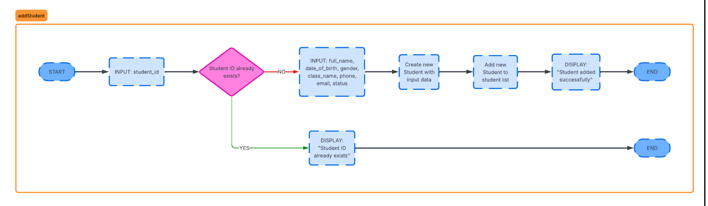
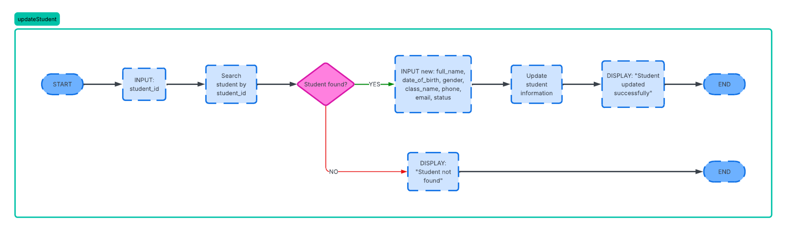
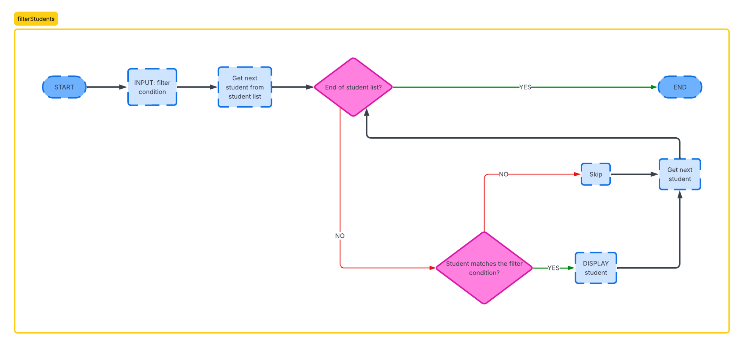
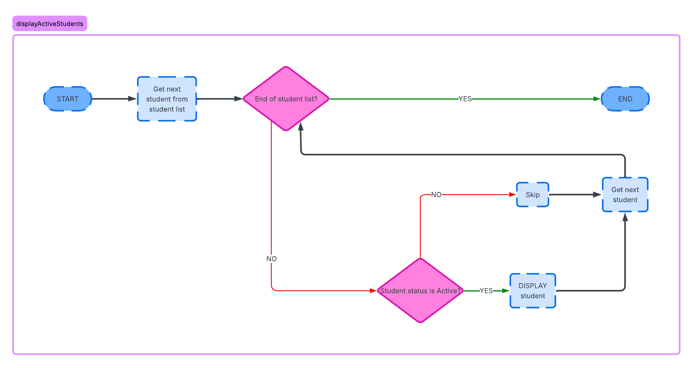

3.3. Result Management & Evaluation Logic
Detailed Function Specification (EvaluateAndSaveScore):
- Core Logic: Implements the automated evaluation rule for passing/failing courses. It sets a default status to "Fail", checks attempt1_Score ($≥5.0$), and if failed, evaluates attempt2_Score ($≥5.0$). It verifies student course registration before updating the database.
Pseudocode:

FUNCTION EvaluateAndSaveScore(studentID, courseID, attempt1_Score, attempt2_Score)
BEGIN
// STEP 1: Set the default status to fail
SET finalResult = "Fail"
// STEP 2: Evaluate scores to determine pass or fail
If attempt1_Score >= 5.0 :
SET finalResult = "Pass"
Else:
// If failed the 1st attempt, proceed to check the 2nd attempt
If attempt2_Score >= 5.0 :
SET finalResult = "Pass"
End if
End if
// STEP 3: Check if the student exists in the course list
SET studentRecord = SearchInDatabase(studentID, courseID)
// STEP 4: Handle data saving or return an error
If studentRecord does not exist :
return "Error: Student is not registered for this course!"
Else:
// Save the new score data to the Database
UPDATE Database(attempt1_Score, attempt2_Score, finalResult)
return "Scores saved successfully! Final result: " + finalResult
End if
END

Flowchart Illustration:
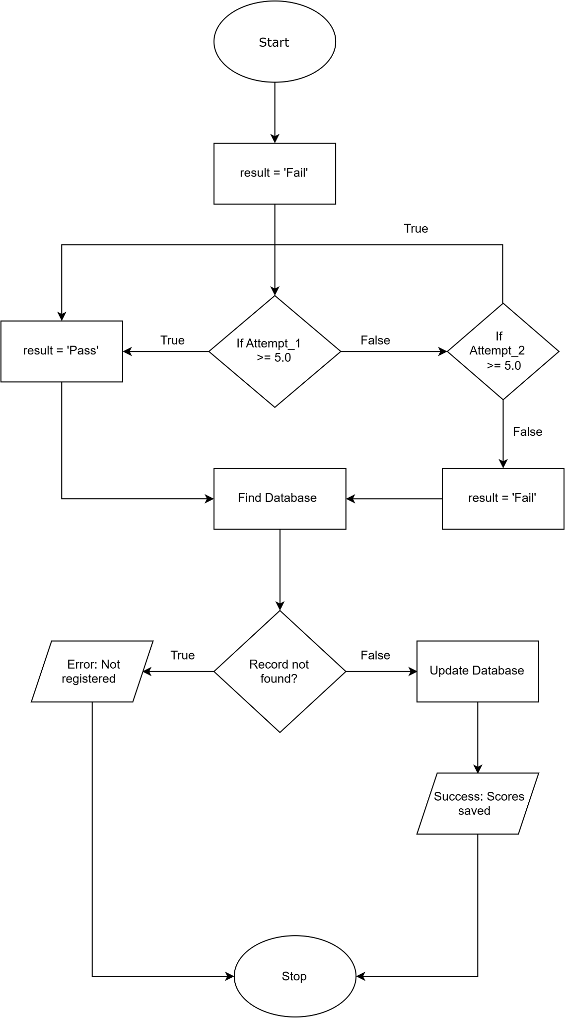

3.4. File I/O & Exception Handling
Detailed Function Specification (loadFromFile & saveToFile):
- loadFromFile: Opens the storage file in read mode, reads line by line, parses objects into memory, and handles FileNotFoundException or IOException safely.
- saveToFile: Opens the file in write mode, serializes and writes data items line by line, ensuring buffer flushing and resource closing in FINALLY blocks.
Pseudocode:

FUNCTION loadFromFile(filePath):
TRY:
// Check and open file
file = OPEN_FILE(filePath, READ_MODE)
dataList = CREATE_EMPTY_LIST()
WHILE file HAS_NEXT_LINE():
line = READ_LINE(file)
item = PARSE_LINE_TO_OBJECT(line)
ADD item TO dataList
END WHILE
RETURN dataList
CATCH FileNotFoundException:
PRINT "Error: File not found at path " + filePath
RETURN EMPTY_LIST
CATCH IOException as e:
PRINT "Error reading file: " + e.getMessage()
RETURN EMPTY_LIST
FINALLY:
IF file IS OPEN THEN:
CLOSE_FILE(file)
END IF
END FUNCTION

FUNCTION saveToFile(filePath, dataList):
TRY:
// Open or create file for writing
file = OPEN_FILE(filePath, WRITE_MODE)
FOR EACH item IN dataList:
line = CONVERT_TO_STRING(item)
WRITE_LINE(file, line)
END FOR
PRINT "File written successfully!"
RETURN TRUE
CATCH IOException as e:
PRINT "Error writing file: " + e.getMessage()
RETURN FALSE
FINALLY:
IF file IS OPEN THEN:
FLUSH_BUFFER(file)
CLOSE_FILE(file)
END IF
END FUNCTION
Flowchart Illustration:
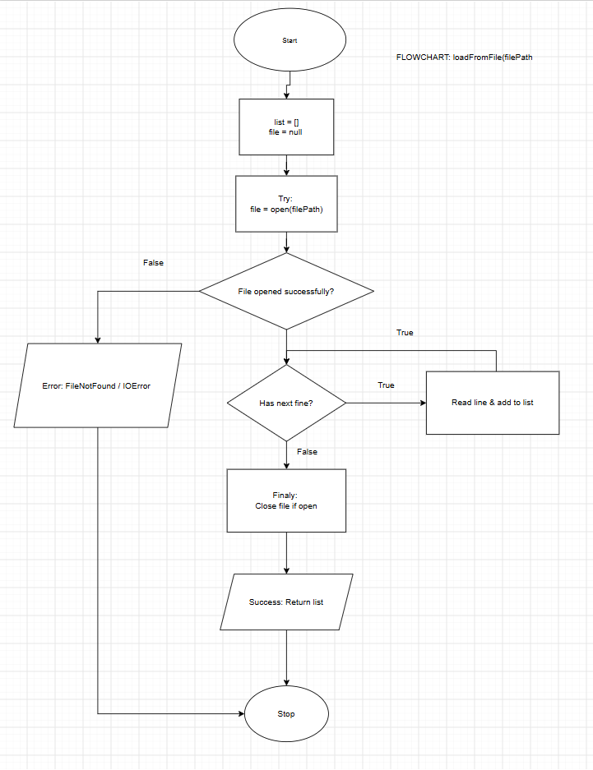
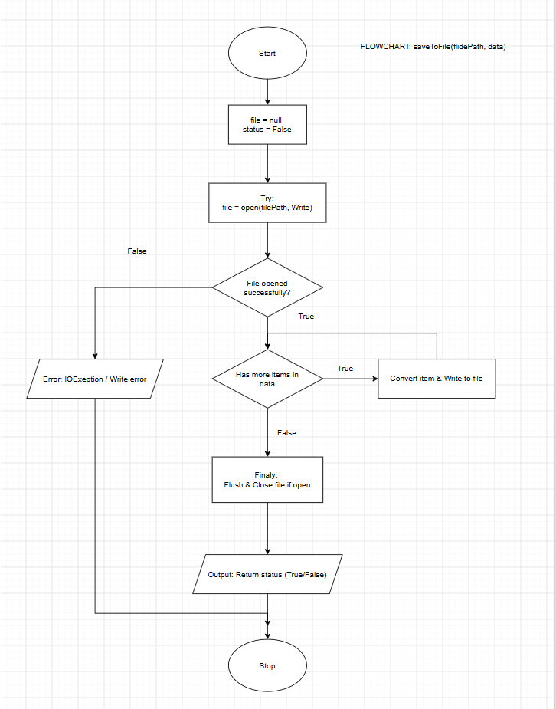

4. Implementation of Basic Functions
This section presents the core Python functions implemented based on the functional decomposition (Section 2.2) and algorithm designs (Section 3). Abstract Data Type (ADT) Mapping & Data Structure Design:
- Record ADT (dict): Each Student and Course Result entity is modeled as a Record using Python dictionaries (dict) containing fixed key-value fields aligned with the Data Dictionary (e.g., student_id, full_name, class_name, status, course_id, grade_fe, grade_re, result_status).
Array / List ADT (list): Collections of records (student_list và result_list) are managed in runtime memory using Python dynamic arrays (list), supporting sequential traversal (for loops), element insertion (.append()), in-place mutation, and conditional filtering.

4.1. Main System Navigation & CLI Menu
- Module Overview: Coordinates application startup, runtime memory initialization via file loading, the main interactive CLI session loop (while True), and automated data persistence upon exit.
- Source Code (main.py - Core Functions):
# =======================================================
# MODULE: MAIN SYSTEM NAVIGATION & CLI
# File: main.py
# Author: Nguyen Thai Huy (SE211528)
# =======================================================

import file_io
import student_management
import result_management

STUDENTS_FILE = "students.txt"
RESULTS_FILE = "results.txt"

def display_main_menu():
print("\n========================================")
print(" STUDENT MANAGEMENT SYSTEM (SMS) ")
print("========================================")
print("1. Student Management")
print("2. Result Management")
print("3. Save and Exit")
print("========================================")

def main():
print("[System] Starting the system...")

student_list = file_io.loadFromFile(STUDENTS_FILE)
result_list = file_io.loadResultsFromFile(RESULTS_FILE)

print(f"[System] Successfully loaded: {len(student_list)} students, {len(result_list)} result records.")

try:
while True:
display_main_menu()
choice = input("Enter your choice (1-3): ").strip()

if choice == "1":
student_management.student_sub_menu(student_list)

elif choice == "2":
result_management.result_sub_menu(result_list, student_list)

elif choice == "3":
print("\n[System] Saving data to the file system...")
save_students_ok = file_io.saveToFile(STUDENTS_FILE, student_list)
save_results_ok = file_io.saveResultsToFile(RESULTS_FILE, result_list)

if save_students_ok and save_results_ok:
print("[System] Data has been saved safely!")
else:
print("[System Warning] An error occurred during the file writing process!")

print("Exiting program. Goodbye!")
break

else:
print("[Error] Invalid choice! Please select between 1 and 3.")

except KeyboardInterrupt:
print("\n\n[System Alert] Forced exit detected (Ctrl+C)!")
print("[System] Performing emergency data save...")
file_io.saveToFile(STUDENTS_FILE, student_list)
file_io.saveResultsToFile(RESULTS_FILE, result_list)
print("[System] Data saved safely. Exiting program. Goodbye!")

if __name__ == "__main__":
main()


4.2. Student Management Module
- Module Overview: Implements the decomposed student profiling functions (addStudent, updateStudent, filterStudents, displayActiveStudents) operating on the student_list Array ADT (list) and individual student Record ADTs (dict)
- Source Code (student_management.py - Core Functions):
# =======================================================
# MODULE: STUDENT MANAGEMENT (CORE FUNCTIONS)
# File: student_management.py
# Author: Tran Vo Hong Ngoc (SE211681)
# =======================================================

from datetime import datetime

valid_prefixes = ["SE", "SS", "SA", "SB", "DE", "DA", "DS", "HE", "HA", "HS", "QE", "QA", "QS", "CE", "CA", "CS"]

def inputStudentID(message, allow_cancel=False):
while True:
student_id = input(message).strip().upper()

if allow_cancel and student_id == "0":
return None

if len(student_id) != 8:
print("Invalid Student ID!")
print("ID must contain exactly 8 characters. Example: SE123456")
elif student_id[:2] not in valid_prefixes:
print("Invalid major code!")
print("Allowed prefixes:", ", ".join(valid_prefixes))
elif not (student_id[2:].isascii() and student_id[2:].isdigit()):
print("Invalid Student ID!")
print("The last 6 characters must be digits (0-9).")
else:
return student_id

def inputName(message):
while True:
raw_name = input(message).strip()
name = " ".join(raw_name.split()).title()

check_name = name.replace(" ", "").replace("-", "").replace("'", "").replace("’", "")

if name != "" and check_name.isalpha() and len(check_name) >= 2:
return name
else:
print("Invalid name! Please enter a valid name.")
print("Use only letters, spaces, hyphens and apostrophes.")
print("The full name must consist of at least two letters.")

def inputEmail(message):
while True:
email = input(message).strip()
if email == "":
print("Email cannot be empty! Please enter an email.")
continue
if len(email.split()) != 1 or not email.isascii() or email.count("@") != 1:
print("Invalid email format! Must contain exactly one '@' without spaces.")
continue
if ".." in email:
print("Invalid email! It must not contain two dots in a row.")
continue

local, domain = email.split("@")
if local == "" or domain == "" or local.startswith(".") or local.endswith("."):
print("Invalid email format!")
continue

domain_parts = domain.split(".")
if len(domain_parts) < 2 or not domain_parts[-1].isalpha() or len(domain_parts[-1]) < 2:
print("Invalid email domain! Example: gmail.com, fpt.edu.vn")
continue

return email

def displayStudent(student):
print("-----------------------------------")
print("Student ID :", student["student_id"])
print("Full name :", student["full_name"])
print("Date of birth:", student["date_of_birth"])
print("Gender :", student["gender"])
print("Class name :", student["class_name"])
print("Phone :", student["phone"])
print("Email :", student["email"])
print("Status :", student["status"])
print("-----------------------------------")

def addStudent(student_list):
student_id = inputStudentID("Enter student ID (0 to cancel): ", allow_cancel=True)
if student_id is None:
print("Operation cancelled. Returning to menu...")
return False

duplicated = False
for student in student_list:
if student["student_id"] == student_id:
duplicated = True
break

if duplicated:
print("Student ID already exists!")
return False

full_name = inputName("Enter full name: ")
date_of_birth = inputDateOfBirth("Enter date of birth (DD/MM/YYYY): ")
gender = inputGender("Enter gender (Male/Female): ")
class_name = inputClassName("Enter class name: ")
phone = inputPhone("Enter phone: ")
email = inputEmail("Enter email: ")
status = inputStatus("Enter status (Active/Inactive/Graduated): ")

new_student = {
"student_id": student_id,
"full_name": full_name,
"date_of_birth": date_of_birth,
"gender": gender,
"class_name": class_name,
"phone": phone,
"email": email,
"status": status
}

student_list.append(new_student)
print("Student added successfully!")
return True

def updateStudent(student_list):
if len(student_list) == 0:
print("Student list is empty! Please add a student first.")
return False

student_id = inputStudentID("Enter student ID to update (0 to cancel): ", allow_cancel=True)
if student_id is None:
print("Operation cancelled. Returning to menu...")
return False

found_student = None
for student in student_list:
if student["student_id"] == student_id:
found_student = student
break

if found_student is None:
print("Student not found!")
return False

while True:
print("\n========== UPDATE STUDENT ==========")
print(f"Updating Student: {found_student['student_id']} - {found_student['full_name']}")
print("1. Update full name")
print("2. Update date of birth")
print("3. Update gender")
print("4. Update class name")
print("5. Update phone")
print("6. Update email")
print("7. Update status")
print("0. Return to main menu")
print("====================================")

choice = input("Enter your choice: ").strip()

if choice == "1":
found_student["full_name"] = inputName("Enter new full name: ")
print("Full name updated successfully!")
elif choice == "2":
found_student["date_of_birth"] = inputDateOfBirth("Enter new date of birth (DD/MM/YYYY): ")
print("Date of birth updated successfully!")
elif choice == "3":
found_student["gender"] = inputGender("Enter new gender (Male/Female): ")
print("Gender updated successfully!")
elif choice == "4":
found_student["class_name"] = inputClassName("Enter new class name: ")
print("Class name updated successfully!")
elif choice == "5":
found_student["phone"] = inputPhone("Enter new phone: ")
print("Phone updated successfully!")
elif choice == "6":
found_student["email"] = inputEmail("Enter new email: ")
print("Email updated successfully!")
elif choice == "7":
found_student["status"] = inputStatus("Enter new status (Active/Inactive/Graduated): ")
print("Status updated successfully!")
elif choice == "0":
print("Returning to main menu...")
return True
else:
print("Invalid choice! Please try again.")

def filterStudents(student_list):
if len(student_list) == 0:
print("Student list is empty! Please add a student first.")
return

filter_condition = input("Enter class name or status to filter (0 to cancel): ").strip().lower()

if filter_condition == "0":
print("Operation cancelled. Returning to menu...")
return

if filter_condition == "":
print("Filter condition cannot be empty!")
return

found = False
for student in student_list:
if (student["class_name"].lower() == filter_condition
or student["status"].lower() == filter_condition):
displayStudent(student)
found = True

if not found:
print("No matching students found!")

def displayActiveStudents(student_list):
if len(student_list) == 0:
print("Student list is empty! Please add a student first.")
return

found = False
for student in student_list:
if student["status"].lower() == "active":
displayStudent(student)
found = True

if not found:
print("No active students found!")

def displayAllStudents(student_list):
if len(student_list) == 0:
print("Student list is empty! Please add a student first.")
else:
for student in student_list:
displayStudent(student)

def student_sub_menu(student_list):
while True:
print("\n========== STUDENT MANAGEMENT ==========")
print("1. Add student")
print("2. Update student")
print("3. Filter students")
print("4. Display active students")
print("5. Display all students")
print("0. Return to main menu")
print("========================================")

choice = input("Enter your choice: ").strip()

if choice == "1":
addStudent(student_list)
elif choice == "2":
updateStudent(student_list)
elif choice == "3":
filterStudents(student_list)
elif choice == "4":
displayActiveStudents(student_list)
elif choice == "5":
displayAllStudents(student_list)
elif choice == "0":
print("Returning to main menu...")
break
else:
print("Invalid choice! Please try again.")


4.3. Result Management & Evaluation Logic
- Module Overview: Implements academic grade tracking and automated course pass/fail evaluation (result_management.py) operating on the result_list Array ADT (list) and individual result Record ADTs (dict)[cite: 10, 11]. Enforces the institutional two-attempt grading rule where a student achieves a "Pass" status if grade_fe >= 5.0 or grade_re >= 5.0.
- Source Code (result_management.py):

# =======================================================
# MODULE: RESULT MANAGEMENT & EVALUATION LOGIC
# File: result_management.py
# Author: Vu Ngoc Anh (SE211294)
# =======================================================

from student_management import inputStudentID

def inputScore(prompt, allow_empty=False):
while True:
raw = input(prompt).strip().replace(",", ".")
if allow_empty and raw == "":
return None
try:
score = float(raw)
if 0.0 <= score <= 10.0:
return round(score, 2)
print("[Error] Score must be between 0.0 and 10.0!")
except ValueError:
print("[Error] Invalid score! Please enter a valid number.")

def inputCourseID(prompt, allow_cancel=False):
while True:
course_id = input(prompt).strip().upper()
if allow_cancel and course_id == "0":
return None
if not course_id:
print("[Error] Course ID cannot be empty!")
elif "|" in course_id or " " in course_id:
print("[Error] Course ID must not contain spaces or '|'!")
elif not (2 <= len(course_id) <= 10 and course_id.isalnum()):
print("[Error] Course ID must be 2-10 alphanumeric characters (e.g. PFP191)!")
else:
return course_id

def evaluateCourseStatus(grade_fe, grade_re):
try:
fe = float(grade_fe) if grade_fe not in (None, "") else 0.0
except ValueError:
fe = 0.0

try:
re = float(grade_re) if grade_re not in (None, "") else None
except ValueError:
re = None

if fe >= 5.0:
return "Pass"
elif re is not None and re >= 5.0:
return "Pass"
else:
return "Fail"

def displayResult(record):
re_grade = record.get("grade_re", "")
re_display = re_grade if re_grade not in (None, "") else "(none)"
print("-----------------------------------")
print(f"Student ID : {record.get('student_id', '')}")
print(f"Course ID : {record.get('course_id', '')}")
print(f"Final Exam : {record.get('grade_fe', '')}")
print(f"Retake Exam : {re_display}")
print(f"Result Status: {record.get('result_status', '')}")
print("-----------------------------------")

def addCourseGrade(result_list, student_list):
print("\n--- ADD COURSE GRADE ---")
student_id = inputStudentID("Enter student ID (0 to cancel): ", allow_cancel=True)
if student_id is None:
print("Operation cancelled. Returning to menu...")
return False

found_student = None
for s in student_list:
if s["student_id"] == student_id:
found_student = s
break

if not found_student:
print(f"[Error] Student ID {student_id} not found in student list! Please add student first.")
return False

if found_student["status"].lower() != "active":
print(f"[Error] Cannot add grade! Student {student_id} is '{found_student['status']}'. Only 'Active' students can take courses.")
return False

course_id = inputCourseID("Enter course ID (e.g. PFP191, or 0 to cancel): ", allow_cancel=True)
if course_id is None:
print("Operation cancelled. Returning to menu...")
return False

for record in result_list:
if record["student_id"] == student_id and record["course_id"] == course_id:
print("[Error] Grade record for this student and course already exists!")
return False

grade_fe = inputScore("Enter Final Exam (FE) grade (0-10): ")
grade_re = None
if grade_fe < 5.0:
print("[System Info] FE score is below 5.0. Retake Exam (RE) can be entered.")
grade_re = inputScore("Enter Re-take Exam (RE) grade (0-10, or press Enter to skip): ", allow_empty=True)

result_status = evaluateCourseStatus(grade_fe, grade_re)

new_record = {
"student_id": student_id,
"course_id": course_id,
"grade_fe": str(grade_fe),
"grade_re": str(grade_re) if grade_re is not None else "",
"result_status": result_status
}

result_list.append(new_record)
print(f"[Success] Grade added successfully! Final status: {result_status}")
return True

def updateGradeOrStatus(result_list, student_list):
print("\n--- UPDATE GRADE ---")
student_id = inputStudentID("Enter student ID to update (0 to cancel): ", allow_cancel=True)
if student_id is None:
print("Operation cancelled. Returning to menu...")
return False

found_student = None
for s in student_list:
if s["student_id"] == student_id:
found_student = s
break

if not found_student:
print(f"[Error] Student ID {student_id} not found in student list!")
return False

if found_student["status"].lower() != "active":
print(f"[Error] Cannot update grade! Student {student_id} is '{found_student['status']}'. Only 'Active' students can have grades updated.")
return False

course_id = inputCourseID("Enter course ID to update (0 to cancel): ", allow_cancel=True)
if course_id is None:
print("Operation cancelled. Returning to menu...")
return False

found_record = None
for record in result_list:
if record["student_id"] == student_id and record["course_id"] == course_id:
found_record = record
break

if found_record is None:
print(f"[Error] No grade record found for Student {student_id} in Course {course_id}!")
return False

print(f"[System] Updating grade for Student {student_id} - Course {course_id}:")
new_fe = inputScore("Enter new Final Exam (FE) grade (0-10): ")

current_re = found_record.get("grade_re", "")
if new_fe < 5.0:
print("[System Info] FE score is below 5.0. Retake Exam (RE) can be entered.")
re_prompt = f"Enter new Re-take Exam (RE) grade (0-10, or press Enter to keep current [{current_re or 'none'}]): "
re_val = inputScore(re_prompt, allow_empty=True)
final_re = str(re_val) if re_val is not None else current_re
else:
final_re = ""

found_record["grade_fe"] = str(new_fe)
found_record["grade_re"] = final_re
found_record["result_status"] = evaluateCourseStatus(new_fe, final_re)

print(f"[Success] Grade updated successfully! New status: {found_record['result_status']}")
return True

def searchEnrollments(result_list):
print("\n--- SEARCH ENROLLMENTS ---")
student_id = inputStudentID("Enter student ID to search (0 to cancel): ", allow_cancel=True)
if student_id is None:
print("Operation cancelled. Returning to menu...")
return

found = False
for record in result_list:
if record["student_id"] == student_id:
if not found:
print(f"\n===== ACADEMIC RECORDS FOR STUDENT {student_id} =====")
displayResult(record)
found = True

if not found:
print(f"[Info] No grade records found for student {student_id}.")

def displayExamResults(result_list):
print("\n--- ALL EXAM RESULTS (SORTED BY STATUS) ---")
if not result_list:
print("[Info] No exam results available.")
return

sorted_results = sorted(result_list, key=lambda x: str(x.get("result_status", "")), reverse=True)
for record in sorted_results:
displayResult(record)

def displayPassedStudents(result_list):
print("\n--- PASSED STUDENTS ---")
passed = [r for r in result_list if str(r.get("result_status", "")).strip().lower() == "pass"]
if not passed:
print("[Info] No passed students found.")
return

print(f"[Info] Found {len(passed)} passed record(s):")
for record in passed:
displayResult(record)

def result_sub_menu(result_list, student_list):
while True:
print("\n========== RESULT MANAGEMENT ==========")
print("1. Add student's course grade")
print("2. Update student's grade or status")
print("3. Search enrollments by student ID")
print("4. Display exam results (sorted by status)")
print("5. Display passed students")
print("0. Return to main menu")
print("=======================================")

choice = input("Enter your choice: ").strip()

if choice == "1":
addCourseGrade(result_list, student_list)
elif choice == "2":
updateGradeOrStatus(result_list, student_list)
elif choice == "3":
searchEnrollments(result_list)
elif choice == "4":
displayExamResults(result_list)
elif choice == "5":
displayPassedStudents(result_list)
elif choice == "0":
print("Returning to main menu...")
break
else:
print("[Error] Invalid choice! Please try again.")



4.4. File I/O & Exception Handling
- Module Overview: Handles persistent plain-text file storage operations (students.txt and results.txt) using the | delimiter[cite: 1, 11]. Implements defensive exception handling (try-except-finally blocks) to intercept FileNotFoundError and general I/O errors safely while ensuring file streams are properly flushed and closed
- Source Code (file_io.py):
# =======================================================
# MODULE: FILE I/O & EXCEPTION HANDLING
# File: file_io.py
# Author: Nguyen Thai Son (SE211746)
# =======================================================

def loadFromFile(filePath):
student_list = []
file = None
try:
file = open(filePath, "r", encoding="utf-8")
for line in file:
line = line.strip()
if not line:
continue
parts = line.split("|")
if len(parts) == 8:
student = {
"student_id": parts[0].strip(),
"full_name": parts[1].strip(),
"date_of_birth": parts[2].strip(),
"gender": parts[3].strip(),
"class_name": parts[4].strip(),
"phone": parts[5].strip(),
"email": parts[6].strip(),
"status": parts[7].strip()
}
student_list.append(student)
except FileNotFoundError:
print(f"[Warning] File not found: {filePath}. Starting with an empty student list.")
except IOError as e:
print(f"[Error] Failed to read file {filePath}: {e}")
finally:
if file and not file.closed:
file.close()
return student_list

def saveToFile(filePath, student_list):
file = None
try:
file = open(filePath, "w", encoding="utf-8")
for s in student_list:
line = f"{s['student_id']}|{s['full_name']}|{s['date_of_birth']}|{s['gender']}|{s['class_name']}|{s['phone']}|{s['email']}|{s['status']}\n"
file.write(line)
return True
except IOError as e:
print(f"[Error] Failed to write to file {filePath}: {e}")
return False
finally:
if file and not file.closed:
file.flush()
file.close()

def loadResultsFromFile(filePath):
result_list = []
file = None
try:
file = open(filePath, "r", encoding="utf-8")
for line in file:
line = line.strip()
if not line:
continue
parts = line.split("|")
if len(parts) == 5:
result = {
"student_id": parts[0].strip(),
"course_id": parts[1].strip(),
"grade_fe": parts[2].strip(),
"grade_re": parts[3].strip(),
"result_status": parts[4].strip()
}
result_list.append(result)
except FileNotFoundError:
print(f"[Warning] File not found: {filePath}. Starting with an empty result list.")
except IOError as e:
print(f"[Error] Failed to read file {filePath}: {e}")
finally:
if file and not file.closed:
file.close()
return result_list

def saveResultsToFile(filePath, result_list):
file = None
try:
file = open(filePath, "w", encoding="utf-8")
for r in result_list:
line = f"{r['student_id']}|{r['course_id']}|{r['grade_fe']}|{r['grade_re']}|{r['result_status']}\n"
file.write(line)
return True
except IOError as e:
print(f"[Error] Failed to write to file {filePath}: {e}")
return False
finally:
if file and not file.closed:
file.flush()
file.close()



5. Object-Oriented Design (OOP)
Transitioning from the procedural dictionary-based design in Section 4, this section details the Object-Oriented Programming (OOP) architecture of the Student Management System. The architecture separates domain entities (models/), business logic and collection managers (services/), and data validation (utils/).

5.1. Class Architecture & UML Class Diagram
The system architecture is structured around five core classes with clear responsibilities:
- Person: Base class representing common human identity attributes.
- Student: Subclass inheriting from Person, adding institutional student metadata (student_id, class_name, status).
- Result: Entity encapsulating academic course results and automated grading rules.
- StudentManager: Service class encapsulating a collection (list[Student]) and its management operations.
- ResultManager: Service class encapsulating list[Result] and enforcing relational rules between students and grades.
System UML Class Diagram:
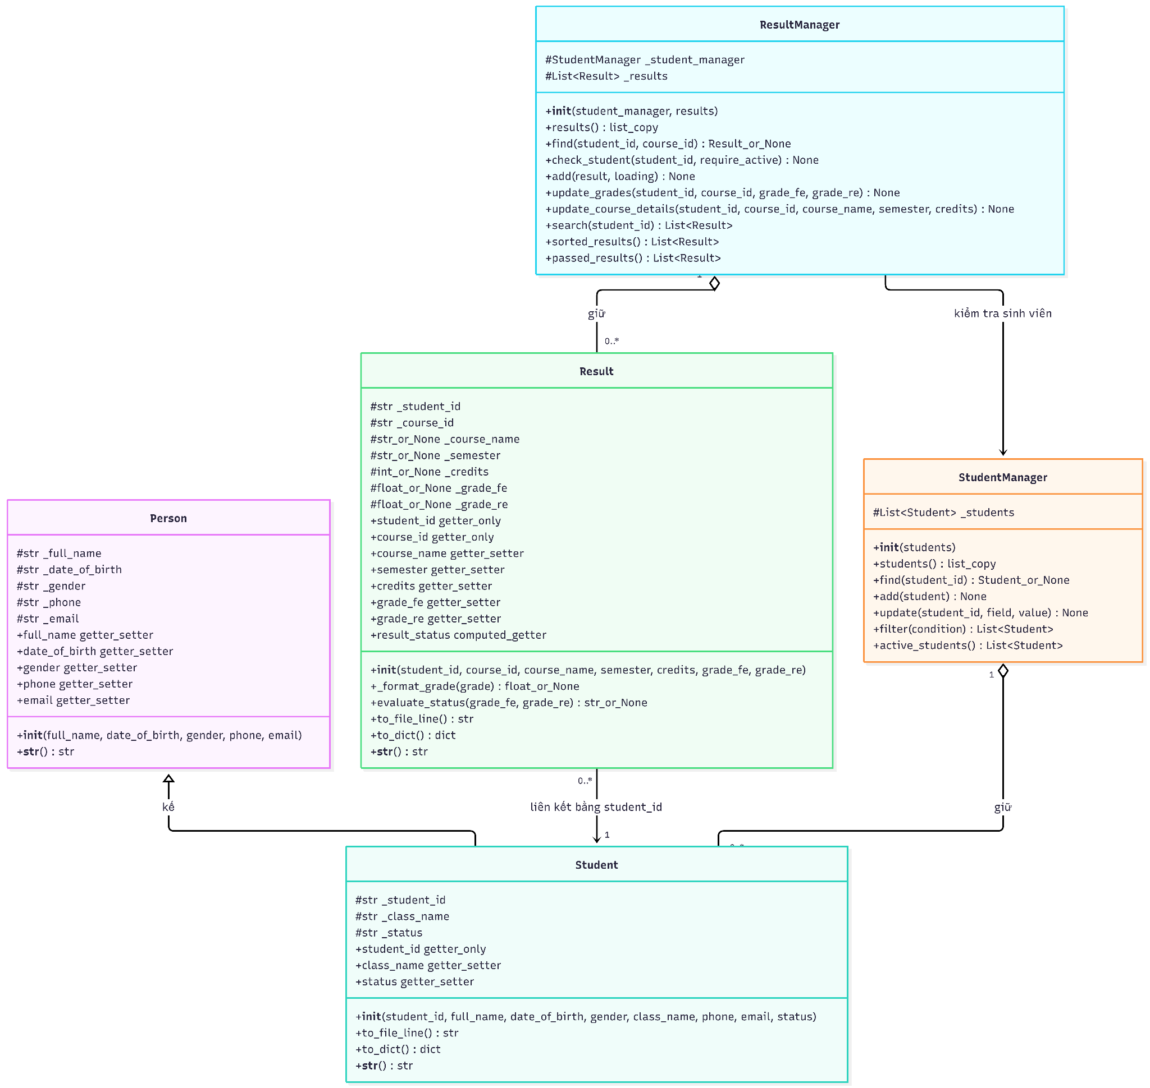

5.2. Domain Model Specifications (models/)
1. Base Class Person ()
The Person class models foundational demographic data. All instance attributes are private (prefixed with _) and guarded by @property getters and setters with centralized validation from utils.validator:
class Person:
def __init__(self, full_name, date_of_birth, gender, phone, email):
self.full_name = full_name
self.date_of_birth = date_of_birth
self.gender = gender
self.phone = phone
self.email = email
2. Derived Class Student ()
Student inherits from Person via super().__init__(). The unique identifier _student_id is exposed only through a getter property without a setter, guaranteeing immutability once created:
class Student(Person):
def __init__(self, student_id, full_name, date_of_birth, gender, class_name, phone, email, status="Active"):
super().__init__(full_name, date_of_birth, gender, phone, email)
self._student_id = validate_student_id(student_id)
self.class_name = class_name
self.status = status

@property
def student_id(self):
return self._student_id
3. Course Result Model Result ()
The Result entity encapsulates academic grading rules. Instead of storing a mutable status string, result_status is dynamically evaluated:
- If grade_fe >= 5.0 or (grade_re is not None and grade_re >= 5.0): returns "Pass".
- If grade_fe < 5.0 and (grade_re is None or grade_re < 5.0): returns "Fail".
If grade_fe is None: returns None (displayed as "Not yet graded" or "N/A")."

5.3. Service Managers and Collection Handling (services/)
The service layer decouples business logic from domain models and data storage. It encapsulates collection-level operations and relationship enforcement between entities.
1. StudentManager Class
Encapsulates an internal list of Student objects. It provides high-level operations such as adding new students (with ID uniqueness checks), updating existing student fields dynamically, filtering by class or status, and querying active students.
2. ResultManager Class
Manages the list of Result objects and holds a reference to a StudentManager instance. This reference enables relational verification—for instance, ensuring a course grade is assigned only to an existing, active student. It also supports querying enrollments by student ID, sorting grade records by result status, and retrieving lists of passed students.

5.4. Application of Core OOP Principles
The following table summarizes how core Object-Oriented Programming principles are applied across the system architecture:
OOP Principle | Implementation in System
Encapsulation | All instance attributes in domain models (Person, Student, Result) are private (prefixed with _). Access and mutations are tightly controlled via @property getters/setters integrated with validation functions.
Inheritance | Student derives from Person, inheriting base personal attributes (full_name, date_of_birth, gender, phone, email) while extending functionality with student-specific attributes (student_id, class_name, status).
Polymorphism / Method Overriding | Domain models override the built-in __str__() string representation method to provide clean, structured console outputs tailored to each entity type.
Abstraction | Complex evaluation logic (e.g., determining course pass/fail status across retake attempts) is encapsulated inside the Result class property, hiding internal score calculation details from external service callers.

6. File I/O & Testing
The system supports saving and reading data from text files (.txt).
Exception handling is applied when the file does not exist or the format is invalid.
Test cases include:
- Adding a valid student
- Searching for a non-existent student
- Handling error when opening a file fails

7. Experimental Results
The program results are demonstrated with screenshots:
[Screenshot placeholder: Main menu, add student, calculate GPA, sorting, file read/write]

8. Appendix
Source Code Repository & File Manifest: main.py, student_management.py, result_management.py, file_io.py.
Persistent Data Stores: students.txt, results.txt.
Complete Input Validation Subroutines: Detailed implementations of inputStudentID(), inputName(), inputDateOfBirth(), inputGender(), inputClassName(), inputPhone(), inputEmail(), and inputStatus() are located in the modular script student_management.py.

